Reference details

Dear ………..
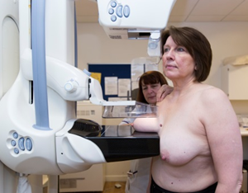  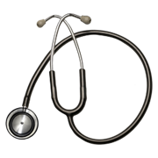 | Thank you for coming for your breast screening appointment. This is called a mammogram.  We need to take some more pictures of your breasts and may need to do some further tests.  You could be seen by both male and female medical staff.  It is important you attend this appointment to help you stay healthy.
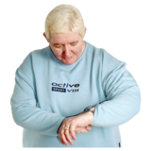  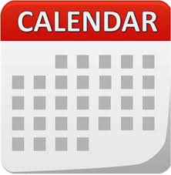 | An appointment has been made for you  on:  at:  Please note your appointment may take several hours.
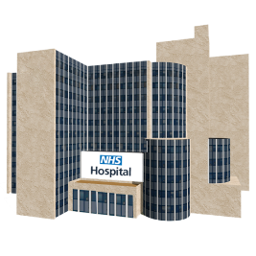 | Please go to:  Picture of Breast Assessment Centre or stock image and address
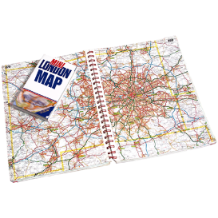 | How to get there:  Map of location, transport details?
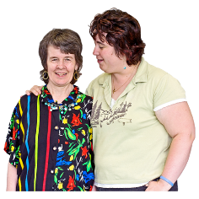 | We think it would be really helpful to bring someone with you.
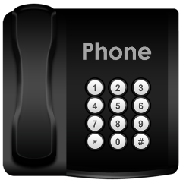  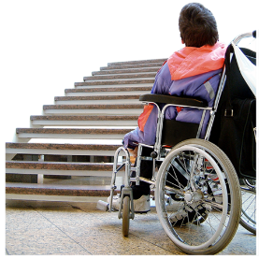 | Please contact us if you do not want your appointment or if you need to change this.  You may also want to tell us about any other needs you have so we can plan for these. For example, if you need more time for your appointment or have a physical disability.  Phone: Number to call
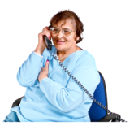  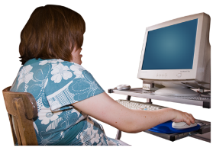 | For more information about breast screening:  - Call the screening centre.  - See the information leaflet  - Talk to your doctor or community learning disability team  - Look online at www.nhs.uk/conditions/breast-cancer-screening

Yours sincerely

